

Creighton Funke

Memorial Scholarship

2002-2023

We are saddened by the passing of our beloved son, brother, friend and eternal Shark, Creighton Funke. Creighton’s spirit will continue through this scholarship sponsored by the

Funke Family via the Community Foundation of Northeast Florida Memorial Funds

and the Ponte Vedra Sharks Booster Club.

Creighton was an admired and respected member of the PVHS Varsity Football and Lacrosse teams. Thinking of others before himself it’s fitting that Creighton’s spirit lives on through the gift of organ donation. He saved 4 lives and gave vision to 2 others.

Creighton embraced the grind, simple pleasures and the brotherhood of being a Shark.

Once a Shark always a Shark.

A $5,000 college scholarship will be awarded to two outstanding Ponte Vedra High School graduating seniors (one male and one female) who have been accepted into an

accredited college or university.

**Requirements**

-3.0 GPA Unweighted (Transcript required for verification)

-Two sport athlete

-Community Service

-Essay and Short Answer

-Copy of College/University Acceptance Letter

\***Deadline, March 23rd.** Must be hand submitted to the Athletic Department Attn. AD Mike Harrison

**APPLICATION WILL BE AVAILABLE ON THE WEBSITE AND SHARKBYTES**



**Creighton Funke Memorial Scholarship**

The Creighton Funke Memorial Scholarship will be awarded annually to two graduating seniors (one girl and one boy) of Ponte Vedra High School who have been accepted into an accredited college or university. In selecting the successful candidates, the review committee, as well as Creighton’s parents Bill and Suzanne Funke, will consider the following:

* Academics/ 3.0 unweighted GPA (Transcript required)
* Community Service
* Athletics/Extracurricular Activities/Performing Arts
* Essay

The Creighton Funke Memorial Scholarship will be in the amount of **$5,000 each**. All applicants must have a minimum 3.0 grade point average (**un-weighted**) and plan to attend an accredited post-secondary institution on a full- time basis. This scholarship rewards and encourages students who demonstrate leadership qualities, a commitment to their community, fellow athletes and students along with the spirit of Team before self. Verification of enrollment from the institution must be received by the Ponte Vedra Shark Booster Club before funds are released.

**NOTE:** **Checks will be made payable to the University. There will be one check each of $5,000 for each of the qualifying seniors.**

This application, acceptance letter from university (if applicable) and **sealed** envelope containing

one teacher/counselor recommendation must be **dated by March 23rd, 2025 and hand submitted to:**

**Mike Harrison**

**Athletic Director**

**Ponte Vedra High School**

**460 Davis Park Road**

**Ponte Vedra Beach, FL 32081**

**\*\* If selected as a finalist, you will be notified by a committee selection member for a possible on campus interview.**



1. Name: ________________________________________________________________________________

Last First Middle

2. Home Address: _________________________________________________________________________

Street City State/ Zip

3. Home Telephone Number: (____) __________________ Cell: ____________________________________

E-mail address: _________________________________Sex: M/F ______ Birth date: ______________

5. Name of the school you plan to attend _______________________________________________________

Have you been accepted? __________ (attach copy of acceptance letter)

6. Academics: GPA: __________ Weighted GPA: __________

7. Hobbies/Interests: _______________________________________________________________________________



1. **What are your plans for after high school?**

(Short answer; Max 150 words)

1. **What does it mean to be a good teammate? Describe a situation where you embodied team before self.**

(Short answer; Max 150 words)

1. **Discuss a situation where you overcame self-doubt and adversity. What created setbacks and what enabled you to succeed?**

(Essay; 400 min-500 max words)



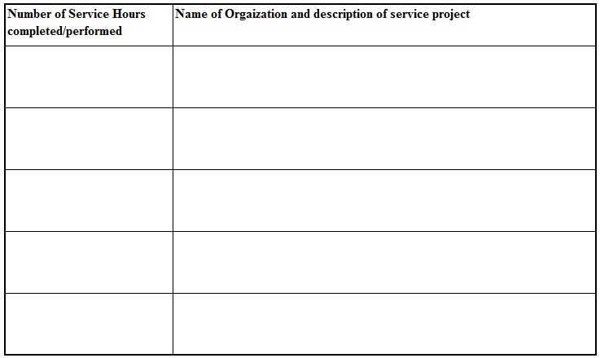

**Guidance Counselor Signature: *_________****_______________________****____***

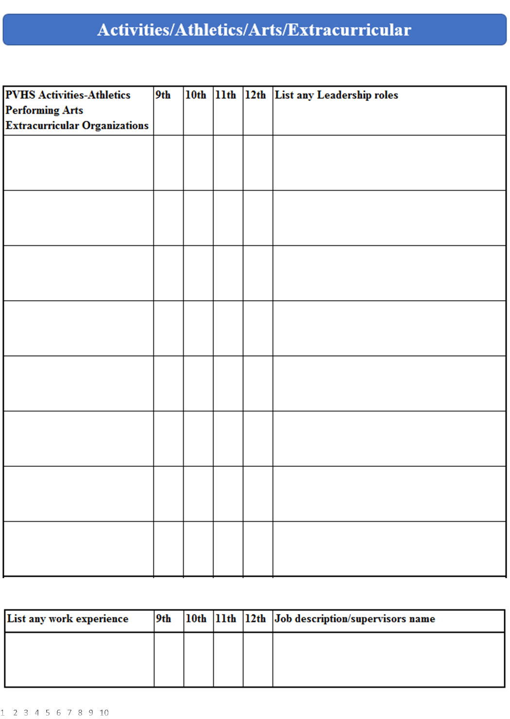

**Submit by March 23rd**

**Hand Submit**

**Creighton Funke/Scholarship**

**Attn: Mike Harrison AV**

**Ponte Vedra HS**

**460 Davis Park Road**

**Ponte Vedra Beach, FL 32081**

**Questions/comments**

[**Michael.Harrison@stjohns.k12fl.us**](mailto:Michael.Harrison@stjohns.k12fl.us)

**Or**

**wpfunke@gmail.com**