2019 Tennis Calendar
- Monday | - Tuesday | Wednesday | Thursday | Friday
Feb 11 | - 12  Bartram 4:00 | Feb 13  JV@ Episcopal | Feb 14  Fleming Island 4:15 | Feb 15  No School
Feb 18  No School | - Feb 19 | Feb 20  @Creekside | Feb 21 | Feb 22  Leon (Home)
Feb 25 | - Feb 26  JV @Bolles 4:30  Stanton 4:15 | Feb. 27  St Augustine | Feb 28  JV -@ Bartram Trail | March 1  Episcopal -4 team tournament  March 2  Episcopal -4 team tournament
March 4  BM | - Mar 5  BM  @Nease | Mar 6  BM | Mar 7  BM | Mar 8  Lake City Columbia  9 Pensacola CC  In Tallahassee
March 11  FW  JV-Home Episcopal | - 12  FW  Clay 4:00 PM  Senior night | 13  FW  @Episcopal | 14  FW  JV –Home Bolles-4pm | 15  FW
March 18  Spring Break | - 19  Spring Break | 20  Spring Break | 21  Spring Break | 22  Spring break
March 25 | - 26 | 27 | 28  HOSA  JV @ Creekside | March 29
April 1 | - April 2  V @ Bolles 4:30  JV@Bishop Kinney | April 3  FW | April 4  FW  @Ridgeview 4pm | April 5  FW
April 8  @ Camden  JV-Home Providence | - April 9 | 10  Fernandina Beach 4:15 | 11 | 12
April 15 | - 16  - DISTRICTS@Bolles | 17  DISTRICTS@Bolles | 18  DISTRICTS -rain date | 19
April 20 | - 21 Regional | 22 | 23 Regional | 24

Feb 12 Bartram Trail (B 6-1 W; G 6-1 L) Mar 9 @ FSU Indoor Facility (vs Pensacola Catholic/ Fort Walton
Feb 14 Fleming Island (B 7-0 W; G 6-1 W) Mar 12 Clay JV
Feb 20 @Creekside (B 3-1 ND; G 6-0L) Mar 13 @Episcopal Feb13 @ Episcopal
Feb 22 Leon (B 7-0 W ; G 4-3 W) Apr 2 @Bolles Feb 26 @ Bolles
Feb 26 Stanton (B 4-3 W; G 7-0 W) Apr 4 @Ridgeview Feb 28 @ Bartram Trail
Feb 27 St Augustine Apr 8 @Camden County Mar 11 Episcopal
Mar1/2@Episcopal (four team tournament) Apr 10 Fernandina Beach Mar 14 Bolles
Mar 5 @Nease Mar 28 @ Creekside
Mar 8 @Lake City Columbia Apr 16/17 Districts at Bolles Apr 2 @ Bishop Kinney
Apr 8 Providence
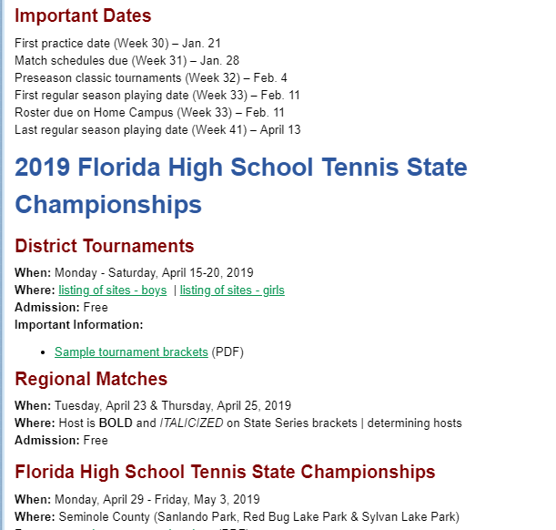2

2018 Varsity Schedule Contacts
St Augustine Girls and Boys Tennis Rob Garrett garrettr@stjohns.k12.fl.us
Bartram Boys and Girls Varsity Cathy French csfmo3@gmail.com
Fleming Island Girls Varsity Moriarty, Micheala micheala.moriarty@myoneclay.net 904-336-7551
3/9 9amPensacola Catholic High@FSUBoys and Girls Varsity Geoff Watts <gsports28@hotmail.com>
Tallahassee Leon Boys and Girls Varsity Record, Kevin recordk@leonschools.net
Creekside Girls Varsity and JV Justin Vogel Justin.Vogel@stjohns.k12.fl.us
Fernandina Beach Boys and Girls Varsity Mark. Durr mark.durr@nassau.k12.fl.us
Bolles Boys and Girls Varsity Danelle Wiggins wigginsd@bolles.org
Bishop Kenny Girls Varsity and JV Jeffery DiSandro disandroj@bishopkennyhs.org
Clay Boys and Girls Varsity Dot Roseberry dotroseberry@bellsouth.net
3/1-2/ @ Episcopal Boys and Girls Varsity Dede Allen allend@esj.org
Ridgeview Boys and Girls Varsity Joy Kay Jody.Kay@myoneclay.net (904)336-8975
4/8 @ Camden Boys and Girls Varsity Daniel Breag <DBreag@camden.k12.ga.us> 912 674 0970
Nease Boys and Girls Varsity Michael Kypriss michaelkypriss@att.net
Menendez Boys and Girls Varsity Steve Melguard Steve.melgard@stjohns.k12.fl.us
Providence Mahha82@yahoo.com or Jeff Alford, jalford@nlcf.org

Fletcher johnsona15@duvalschools.org

2018 JV
Feb 27 Episcopal Boys and Girls Dede Allen allend@esj.org
Mar 1 Creekside Girls Justin Vogel Justin.Vogel@stjohns.k12.fl.us
Mar 14 Bishop Kenny Girls Jeffery DiSandro disandroj@bishopkennyhs.org
Mar 22 Episcopal Girls Dede Allen allend@esj.org
Apr 3 @Keystone Heights Girls Apryl Coleman Apryl.coleman@myoneclay.net
Providence

