The College Application Process

Reference Guide

Overview
Keep track of the colleges that you are applying to by using the Colleges I’m Applying To list. This list provides an overview of the college, the college deadline, transcript requests, and whether the application was submitted allowing you to easily keep track of your college application process. Additionally, view other college application information like requests for letters of recommendation, college events, and test scores.

Accessing the List
- From Naviance Student, Colleges > Colleges I’m Applying To.
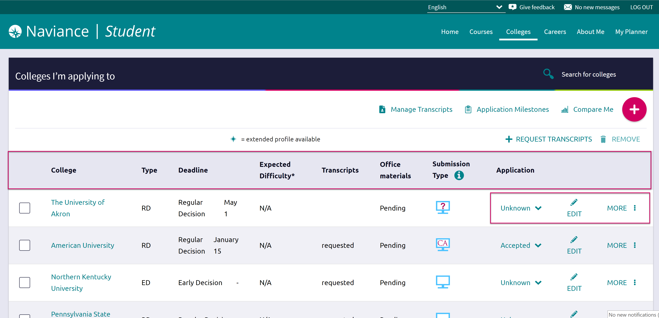

Adding a College(s) to the List & Requesting Transcripts
Colleges can be added to the Colleges I’m Applying To list in two different ways:
- From the Colleges I’m Applying To list
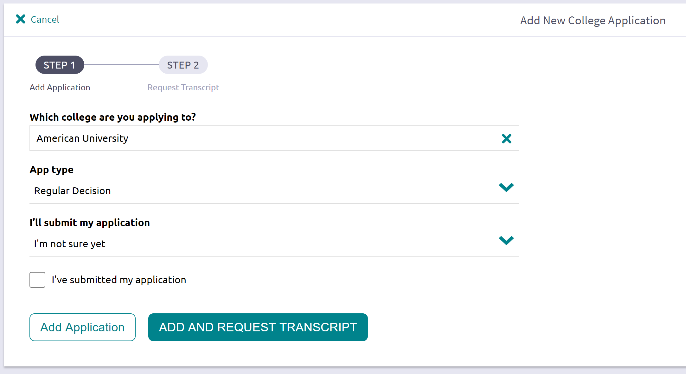
- From the Colleges I’m Thinking About list

From Colleges I’m Applying To
- Click the Add button (+ sign).
The Add New College Application, Step 1 Add Application displays.
- From Which college are you applying to? use the drop-down or type the name of the desired college and select from the matches.
- From App Type click the drop-down to identify your answer.
- From I’ll submit my application? click the drop-down to identify your answer.
- If you have already sent in your application, select the checkbox labeled I’ve submitted my application. If not, leave it unchecked.

If you currently do not need to request transcripts, select Add Application.
- Click Add and Request Transcript.
The Add New College Application – Step 2 Request Transcript displays.
- From What type of transcript/s are you requesting? select the checkbox(es) that identify your answer.
- From What additional materials, if any, do you want included? select the checkbox(es) that identify your answer.
- Review Where are you sending this transcript? to ensure the proper college name is displaying.
- Click Request and Finish.

From Colleges I’m Thinking About
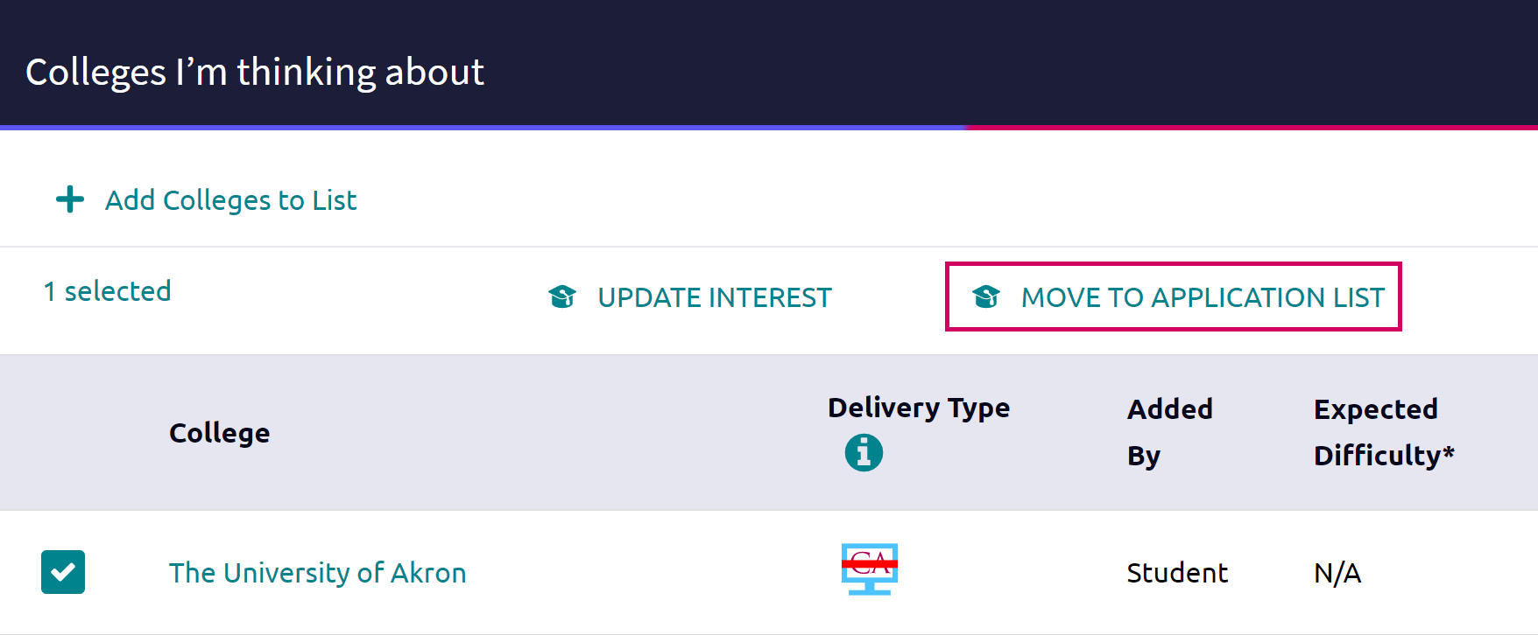
- From Naviance Student, navigate to Colleges > Colleges I’m Thinking About.
- Place checkmarks in the checkboxes next to the schools to which you are applying.
- Click Move to Application List.
The Move to College Applications, Step 1: Add Application/s displays.
- Use the drop-down menus to select the accurate responses.
- If you have already sent in your application, select the checkbox labeled I’ve already sent my application. If not, leave it unchecked.

If you do not currently need to request transcripts, select Add Applications.
- Click Add and Request Transcripts.
The Move to College Applications, Step 2: Request Transcripts displays.
- Select the accurate checkbox(es) for What type of transcript/s are you requesting? and What additional materials, if any, do you want included?.
- Review Where are you sending this transcript? to ensure the proper college name and deadline type is displaying.
- Click Request and Finish.
The college is added, and the request is made.

Request Transcript
A transcript can be requested for schools that were previously saved to your Colleges I’m Applying To list.
- From Colleges I’m Applying To, click Request Transcripts.
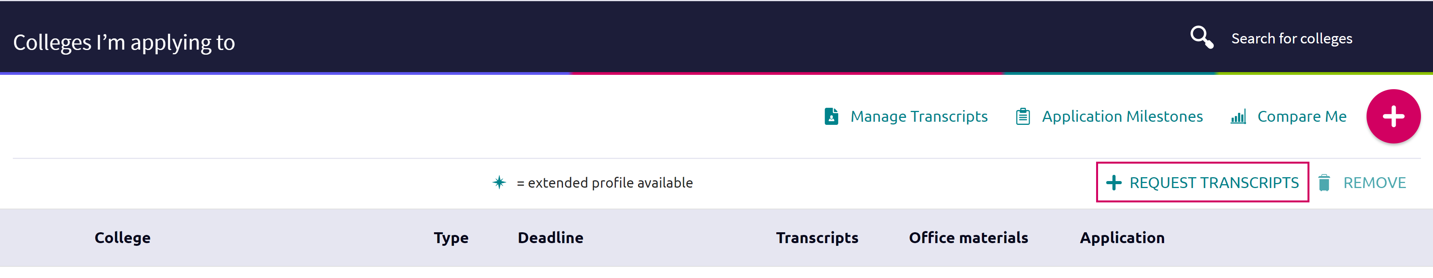
The Request College Application Transcript displays.
- Use the checkboxes and drop-downs to answer the transcript-related questions.
- Click Request and Finish.

Manage Transcripts
Use Manage Transcripts to keep track of your general transcript requests, whether for college applications or scholarships.
- From the Colleges I’m applying to list in Naviance Student, click Manage Transcripts.
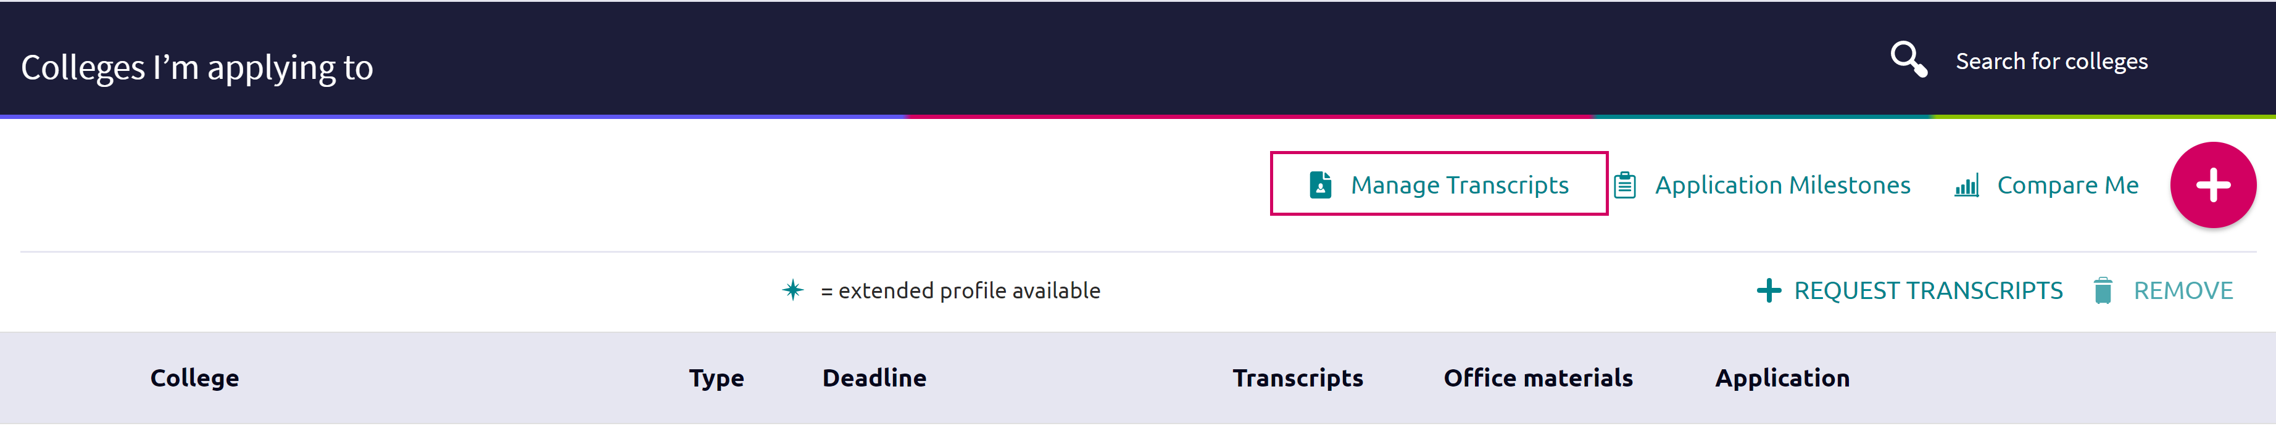
The Manage Transcripts page displays.
- Here you can see all the institutions to which a transcript request has been associated.

- Use the Add (+) button to add either College Application Transcript or Other Transcript.
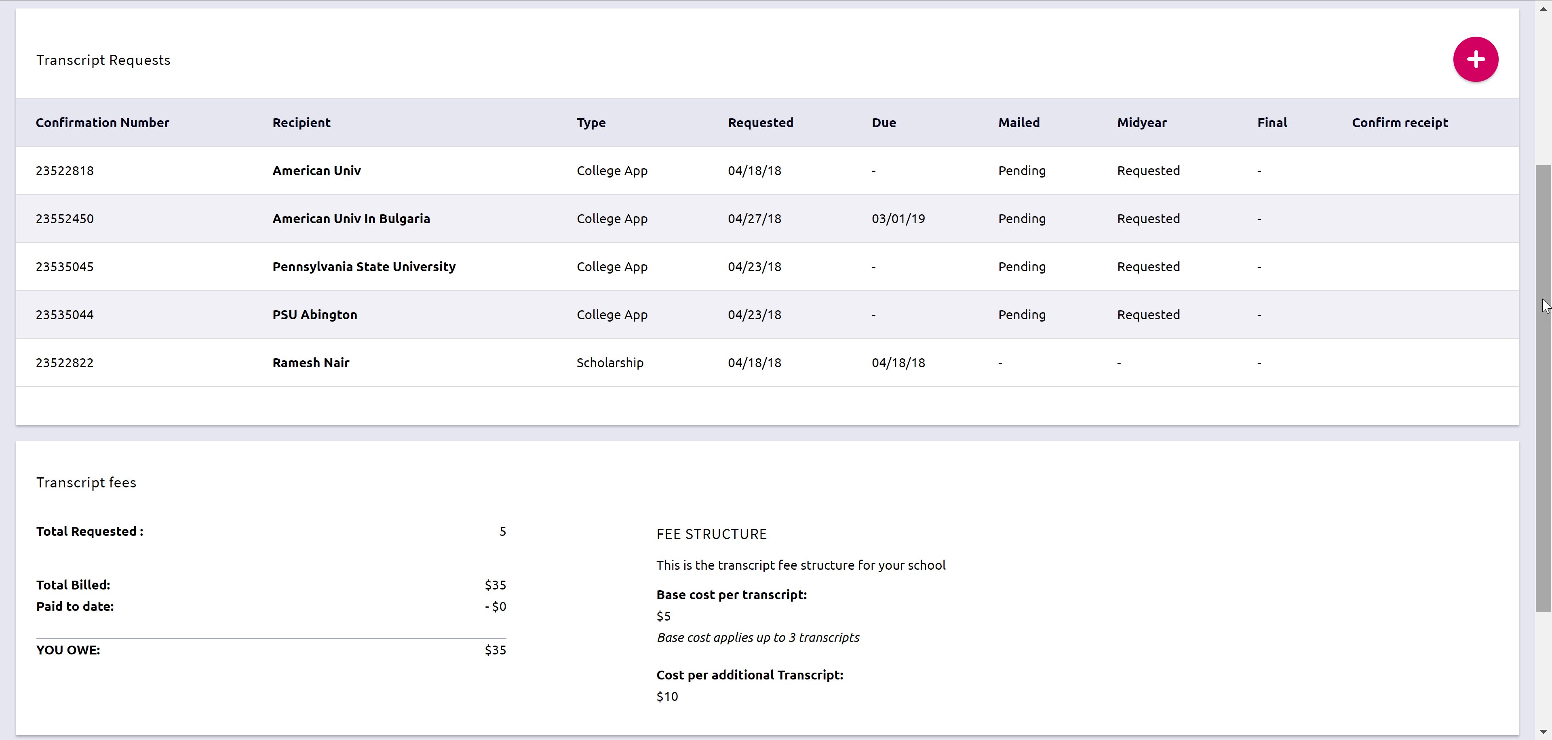
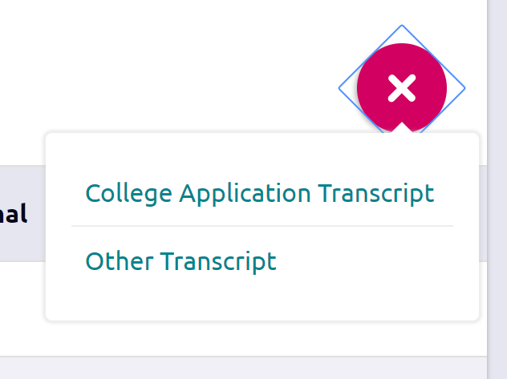
- Use the checkboxes and drop-downs to answer the transcript-related questions.
- Click Request and Finish.
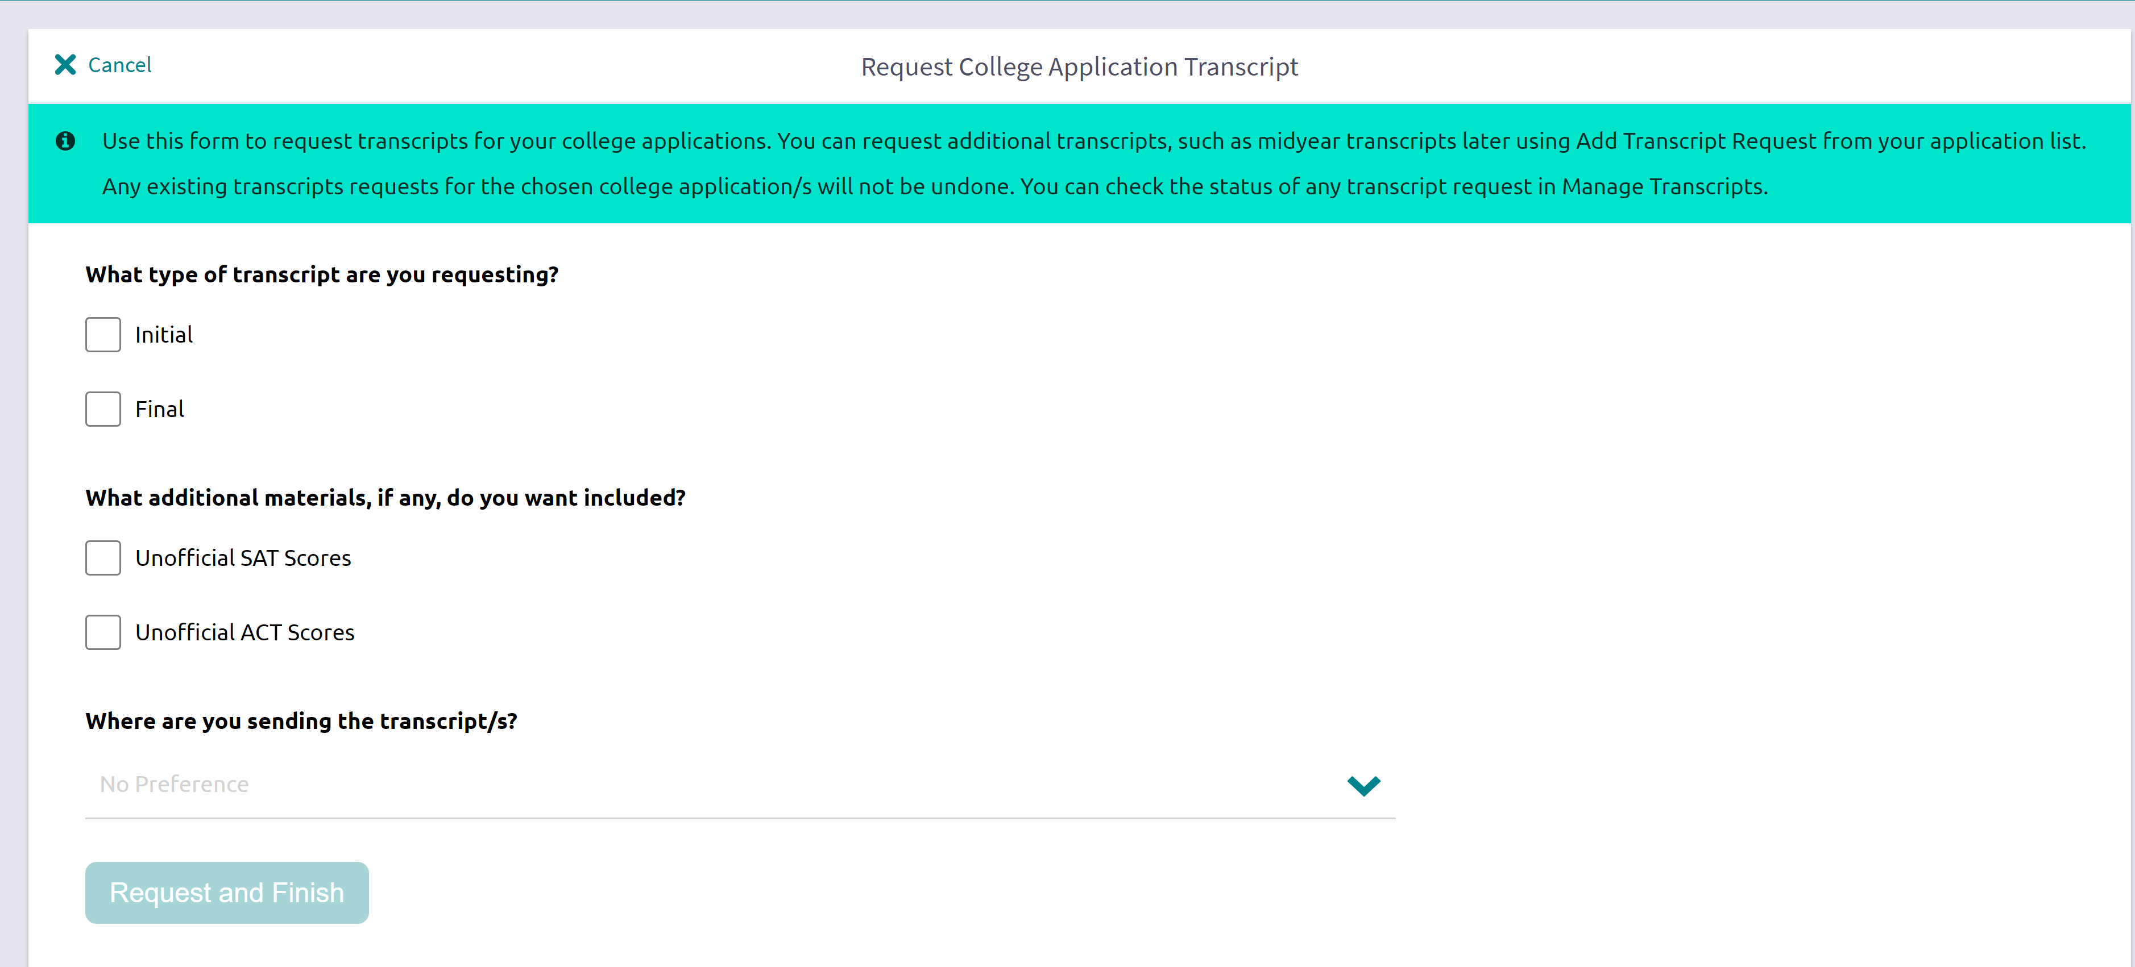

Other Application Information

Letters of Recommendation
Request new and keep track of letter of recommendation requests from Colleges > Apply to College > Letters of Recommendation.
When adding a request, select a teacher to write the recommendation, specific colleges from your Colleges I’m Applying To list, and any notes to share with your teacher.

Test Scores
View and add key test scores (College Home > Apply to College > Test Scores) such as ACT and SAT.

Some schools may not have provided rights to add your own test scores.

