REGISTRATION
To be completed by parent or guardian. Please complete all sections in ink only.

2015 Boys Soccer Camp
(please check one)

Advanced Camp (Boys ages 14-18 ) - $120/player

_______Session I: July 27-July 30 Monday-Thursday

Time: 9:00AM – 11:00AM
Location: Ponte Vedra High School

Name ____________________________________________

School in Fall 2014 _________________ _________________

Grade in Fall 2014 ___________________________________

Address ____________________________________________

City _______________ State _________ Zip ________

Home Phone ___________________________________

Cell Phone ___________________________________

Parents Names ___________________________________

Parents Email ___________________________________

T Shirt Youth S M L

Adult S M L XL
(circle one)

Please make all checks payable to
And mail to:
Shark Summer Camps
217 South Mill Ridge Trail, Ponte Vedra Beach, FL 32004

Activity

Daily Schedule

8:45 Check-in and Warm up
9:00 Technical and Tactical Training
- Shooting
- Dribbling
- Passing, Crossing
- Finishing
- Defending
- Speed and Agility
10:30 Small/Full Sided Games
- Team Formations
- Tactical Training
11:00 Cool Down and Pick Up

Our Mission:
At Ponte Vedra High School we focus on individual development, both on and off the field, to help mold future leaders in the community.
Our goal is to create a fun learning environment in which players can advance their skills while relating them to game situations.
Medical Information
Release
I grant permission for the Shark Sports Camp medical and coaching staff to administer first aid and/or provide transportation to a medical facility to receive adequate medical care in the event of any injury or illness to my
child, _______________________________________________________
Signed __________________________________________________ parent
Indemnity Waiver

I hereby request that you accept this registrant to the Shark Sports Camp during the dates set forth in this application. I hereby release Shark Sports Camps, Inc and all of its employees and independent contractors from any claims on account of injuries that may be sustained by my

child,_____________________________ while attending this camp.

Signed __________________________________________________ parent
Medical Release/Screening

Campers must provide a current, completed medical release form or have a physician complete the following:

____ Check if medical release form provided
or
I have examined the camper named on this form and found the camper to be free from any conditions that would limit the camper from participating in athletics.

Physician’s Name ________________________________________

Physician’s City & State ______________________________

_________________________________________________ __________
Physician’s Signature Date

Insurance

All Shark Sports Camp participants are covered by a secondary insurance policy with limited benefits. The primary health and accident insurance for this camp is that held by the camper and his/her family.

For More Information 904-735-5437

Meet the Coaches:
Daniel Villarreal In over 10 years of coaching in the Jacksonville area Coach Daniel Villarreal has coached boys and girls of all ages and skill level. The once standout player for Jacksonville University, Daniel has brought his knowledge and passion as a player to the world of coaching in collegiate (University of North Florida), high school (Ponte Vedra High School) and club (Ponte Vedra Soccer Club) settings.
At JU Daniel received many accolades during his tenure; including Freshman of the Year, 1st Team All Sun Belt Conference, and voted to JU’s Team of the Decade(90’s). His success has continued off the field as a coach by winning seven State Championships: St. John’s Country Day High School Boys Varsity (2005), Clay County Soccer Club (U15 Girls 2006 and U16 Girls 2007), Ponte Vedra Storm (U16 Girls 2011, U15 Girls 2013, U16 Girls 2014), and Ponte Vedra High School Boys (3A 2013) . His experience and dedication to the sport has helped his players develop their game for the next level.
Coach Thomas Senecal brings unique knowledge of the game due to his playing experience at different levels of the game. Thomas was a notable collegiate player at the University of Kentucky, as a three--time First Team All Conference USA and MAC selection. After Kentucky, his game was elevated to the -professional level (A League) by playing for the Virginia Beach Mariners and Cincinnati Kings.
Gerrit de Boer serves as Head Coach for the Ponte Vedra High School Junior Varsity Boys soccer team, which finished undefeated in 2013 and 2014. He has been coaching soccer in the Jacksonville area since 2006, including time at UNF, Jacksonville Youth Soccer Club, and Bolles High School. In addition, Gerrit has worked many collegiate camps in the Southeast for Clemson University, Furman University, College Of Charleston, Jacksonville University, and UNF. He has also been on Tony DiCicco’s SoccerPlus Goalkeeper staff since the 2013 summer camp season. One of Gerrit’s most recent accomplishments was being an Assistant Coach to the staff that led Ponte Vedra High School’s Varsity Boys soccer team to the 2013 Class 3A State Championship. Gerrit attended Jacksonville University and played all four years of his Division 1 collegiate career as a goalkeeper. He received Academic All-Conference all four years and graduated with a Bachelor of Science degree in Geography.

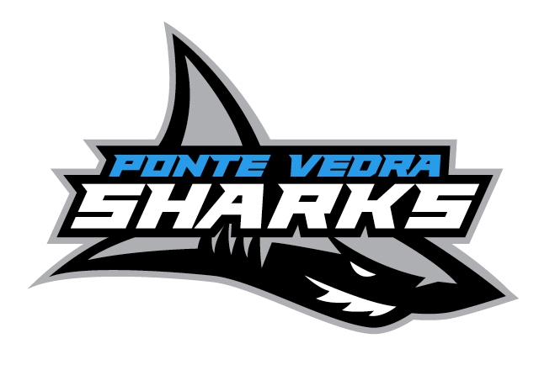

Shark Sports
Camps
Presents
2015 SOCCER Camp
with
Ponte Vedra Head Coach Daniel Villarreal
and
Members of the
3A State Championship
Ponte Vedra High School
Soccer Team
Ponte Vedra High School’s Official Summer
Training Camps

